Pass data to template for dynamic data rendering in template

in MVC structure every data should comes from controller because controller interact with database and send data to view for requested route and pass that data to template for rendering.

Step 1:

Open controller and add hardcoded list of users in controller, we will pass this user list to template from route and template engine will read & convert into normal text that user will understand.

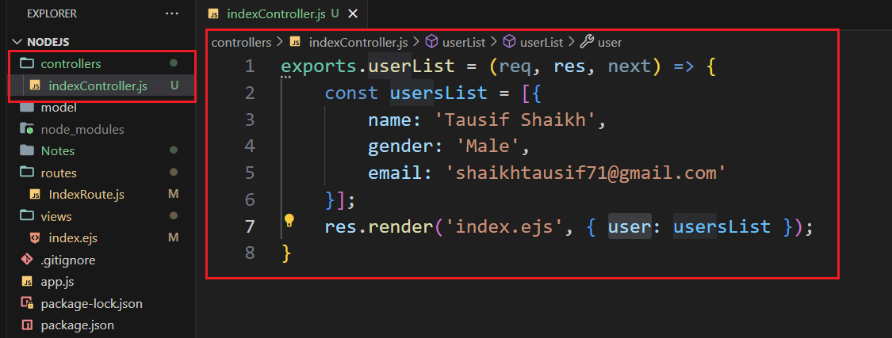

Step 2:

Now import this user controller into router and pass second argument as request and response, as shown below.

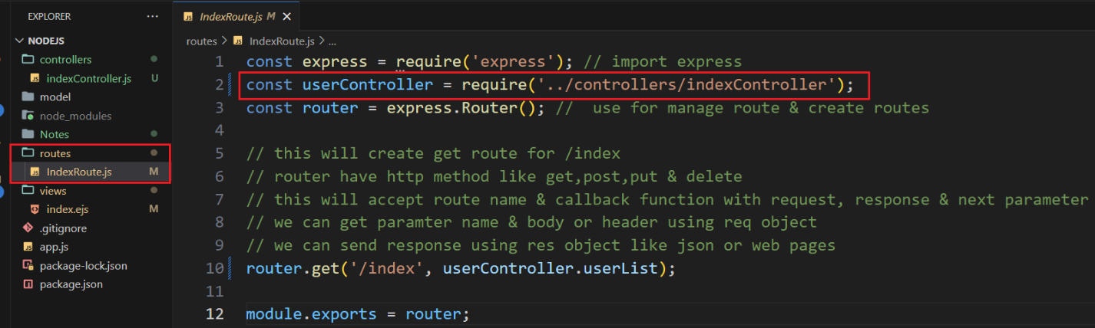

Step 3: in view we will loop user object using ejs syntax as shown below.

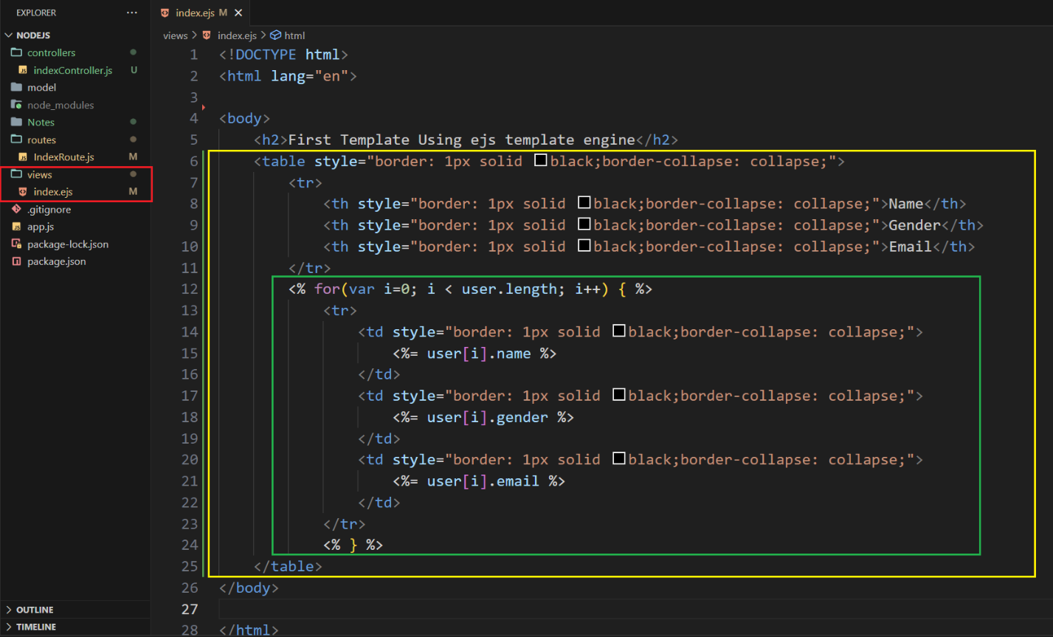

Step 4:

Open browser and enter route to view page with dynamic data as shown below.

